**CS558: Computer Systems Lab**

**Assignment 2 – Network Simulation using Cooja**

**Group -4:**

**1) Bhaskar Sharma - 204101018**

**2) Avik Samanta - 204101016**

**3) Ashish kumar - 204101015**

**4) Rahul Ballani – 204101017**

**Question-4 :**

1. **Introduction : Contiki** is an [operating system](https://en.wikipedia.org/wiki/Operating_system) for networked, memory-constrained systems with a focus on low-power wireless [Internet of Things](https://en.wikipedia.org/wiki/Internet_of_Things) devices. **Cooja** is an extended java based simulating tool which allows us to simulate small- and large-scale networks. Cooja is mainly used for contiki development. It also helps us to test the code before it implemented in the target hardware device.

**2)Problem Statement :** In Time Slotted Channel Hopping (TSCH) and Routing over Low Power and Lossy Networks (RPL) based Low power and Lossy Networks (LLN), new nodes (pledges) join the network one by one. At the beginning, this kind of network formation is started by the RPL root node or TSCH coordinator node. The pledges need to receive network advertisement information carrying Enhanced Beacon (EB) frame to get synchronized with the TSCH network. Similarly, pledges complete their joining process once they receive routing information carrying RPL DIO packet. Pledges are called 6TiSCH joined node once they complete their joining process (i.e., receive both the EB and DIO packets successfully). Both the TSCH joining/ synchronization time and 6TiSCH joining time is very much important for resource constrained LLN devices. In this assignment, both the joining times (i.e., TSCH synchronization time and 6TiSCH joining time) need to be calculated using the Contiki-NG based Cooja Simulator.

* Results should be obtained by varying both the number of shared cells per slotframe. The number of shared cells per slotframe should be as follows: 1, 2, 4, 8, 10. Also count the number of transmitted EB and DIO packets by all the nodes till the formation of the network with each setting.

**3)Parameters Used:**

* Slotframe length (SF) : <31,101>
* Timeslot duration : 10ms
* RPL version : RPL Lite
* No of Channels : 16
* Topology : 5*5 grid topology (25 nodes)
* Radio distance between two nodes(X,Y) : 150
* Radio range : 50 metre
* Interference range :75 metre
* Scheduling Function : 6TiSCH minimal configuration scheduling

**4) Code changes:**

1. Slotframe Length: We can set this by writing

**#define TSCH_SCHEDULE_CONF_DEFAULT_LENGTH 31** inproject-conf.h or we can also change it from tsch-conf.h.

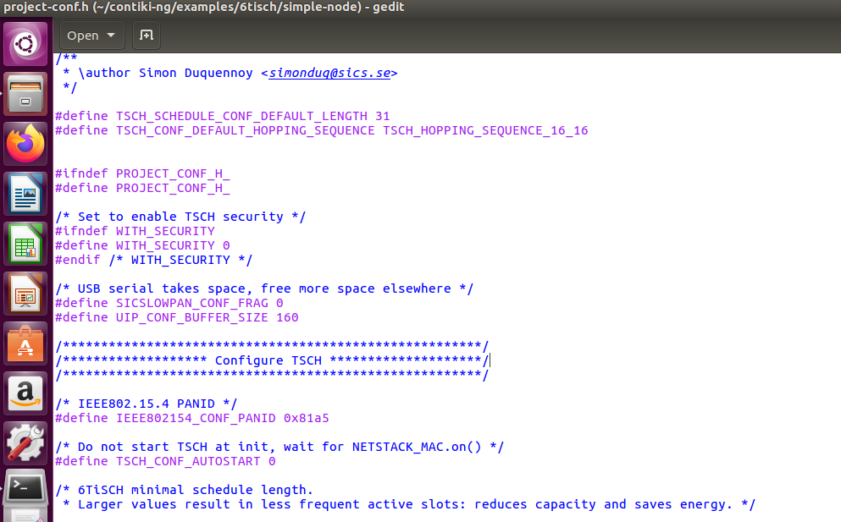

1. **Hopping Sequence** : we can set this by writing

#define TSCH_CONF_DEFAULT_HOPPING_SEQUENCE TSCH_HOPPING_SEQUENCE_16_16 in projectconf.h or we can also change it from tsch-conf.h.



1. **Varying Slot frame size and channel according to no of cells in tsch-schedule.c -**

**tsch_schedule_add_link(sf_min,(LINK_OPTION_RX|LINK_OPTION_TX|LINK_OPTION_SHARED|LINK_OPTION_TIME_KEEPING), LINK_TYPE_ADVERTISING, &tsch_broadcast_address,0, 0, 1);**

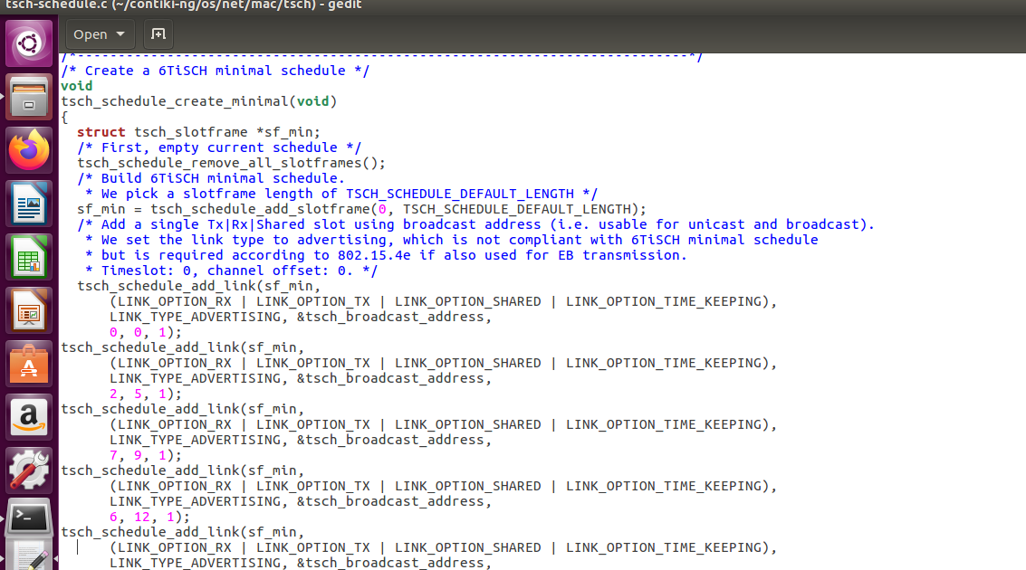

1. The number of shared cells per slot frame can be set in tsch-const.h-

**#define LINK OPTION SHARED 8**

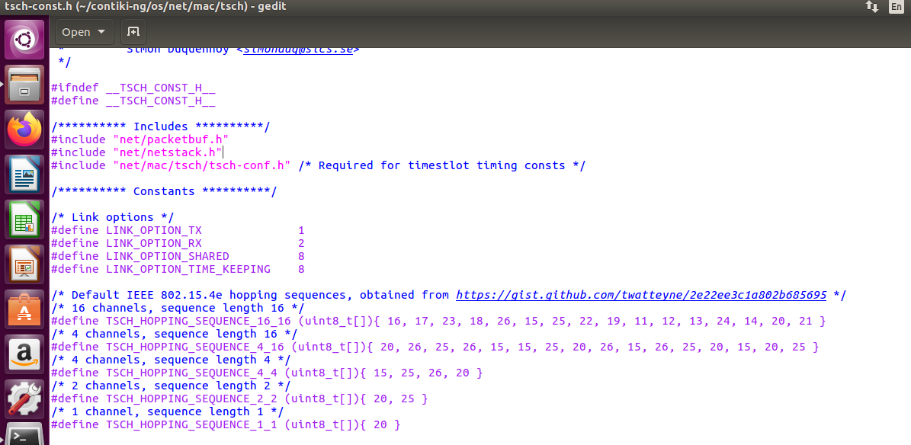

**5) Observations: We have mentioned all the EB ,DIO time and count in an excel file by changing number of shared cells per slot frame (please check the attached excel files for the observations).**